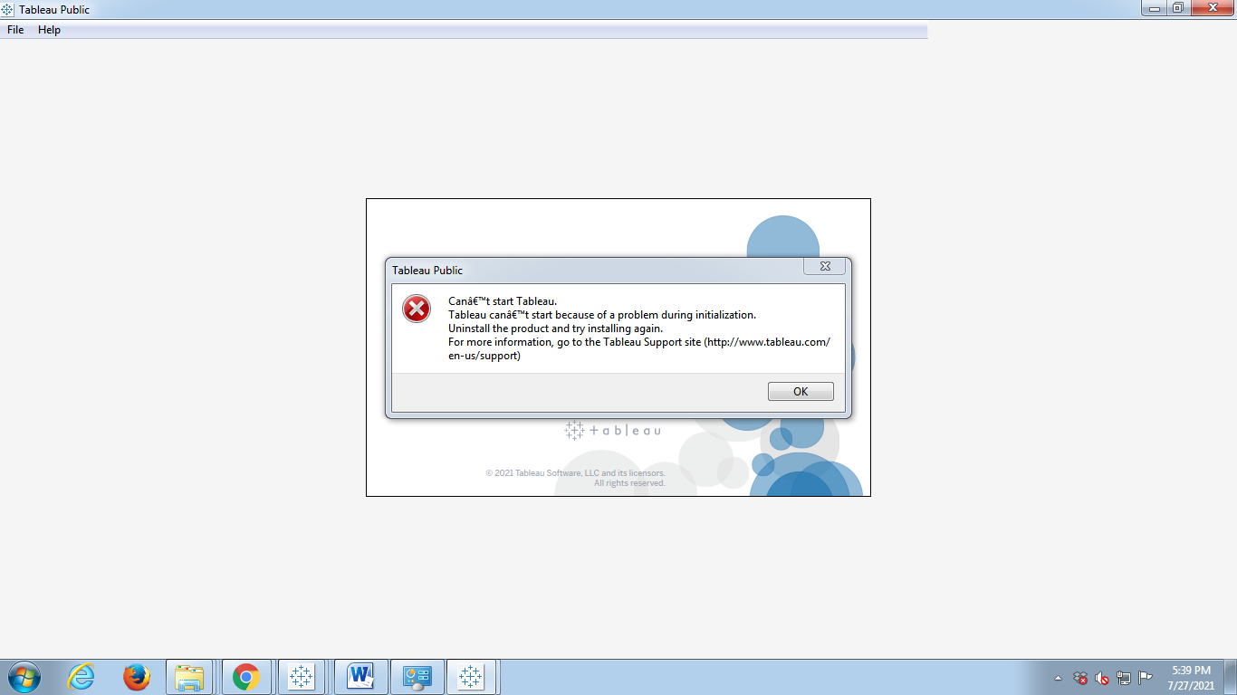

Hi mam, I am not able to open my tableau public as it has error saying “ Tablue cannot start because of a problem in installation”, I tried re-installing many times but same error pop outs.